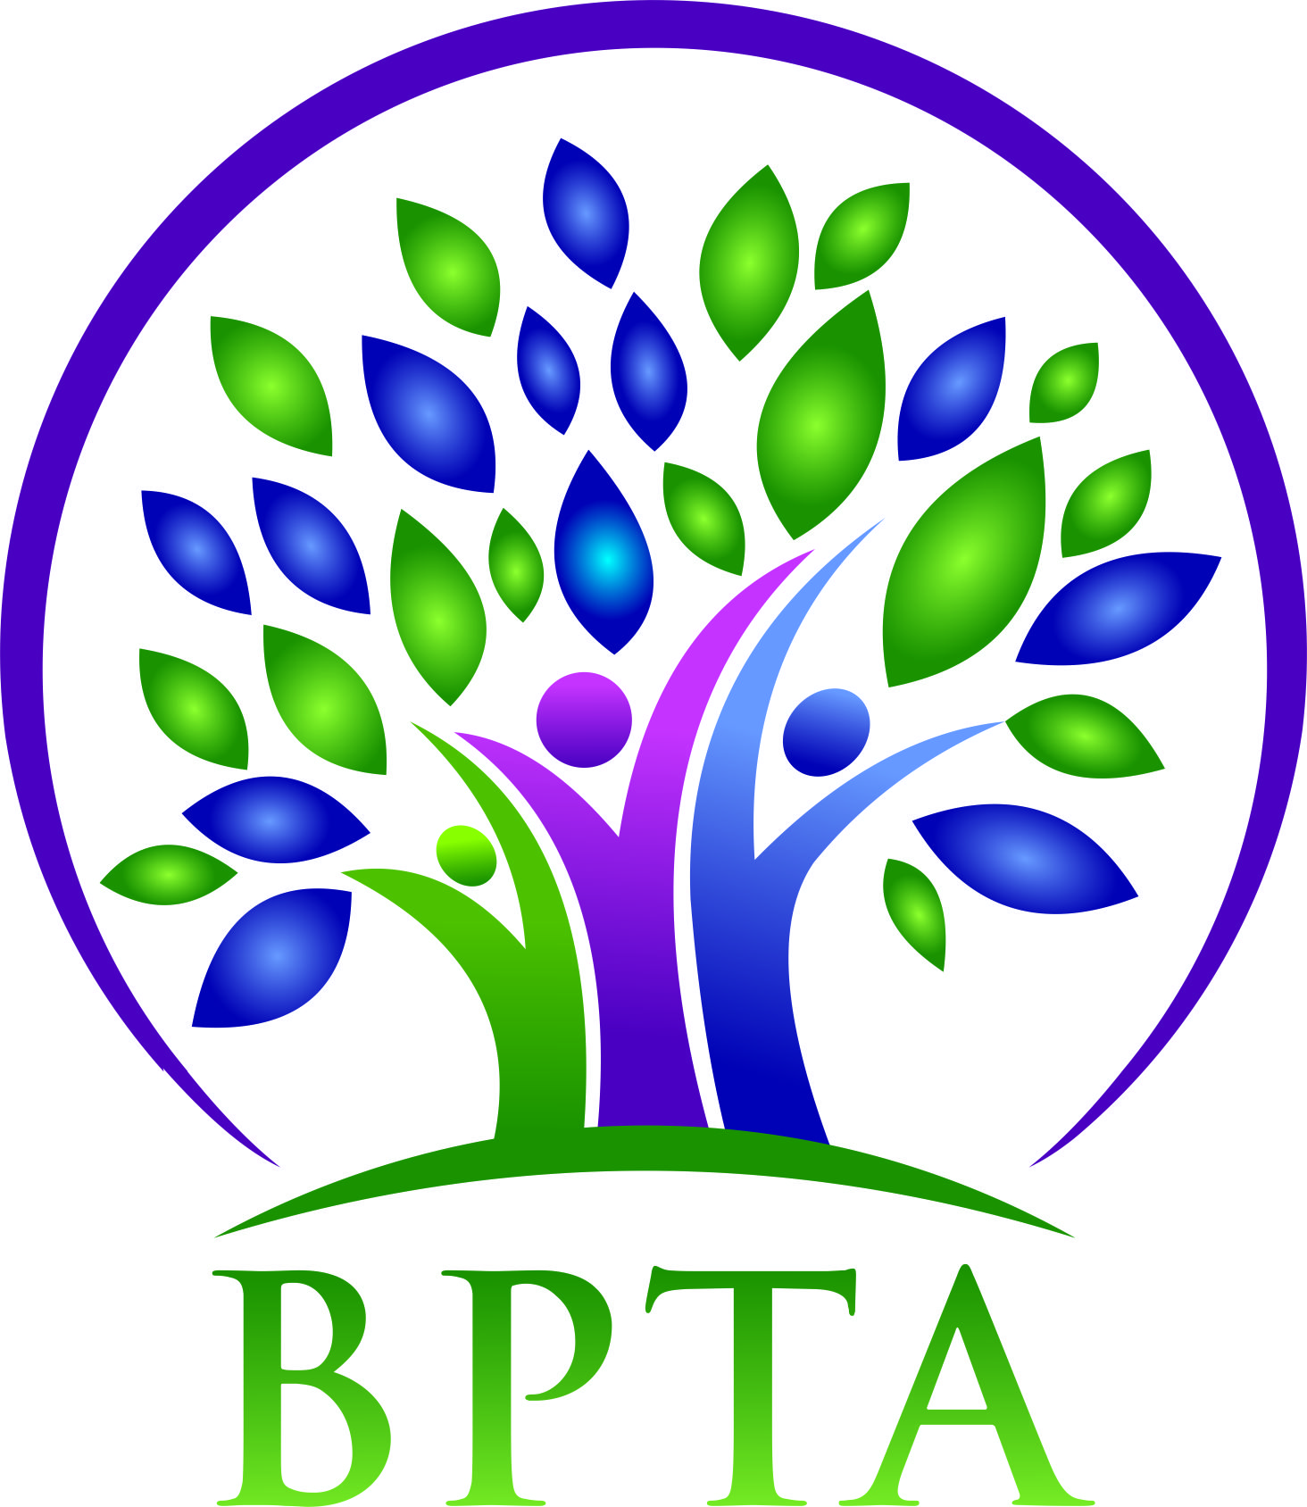
Beautiful Plains Teachers’ Association
Wednesday, June 8, 2022
Neepawa, MB
{zoom}

In attendance: Allen Hanke (HMK) Robyn Forsman (Brookdale)
Sheena Taylor (HMK) Val Parayeski (NMS) Trish James (JM Young) Mike Adams (NACI) Kerry Turner (NACI) Michelle Kolbe (NMS) Ashlee Plett (HMK) Raelynn Jacobson(Willerton) Peter Reid (NACI) Brent Boyle (CC)

Regrets: Kelvin Hollier (NACI) Denise Selewich (NMS)
Susan Barteaux (RJ Waugh)

- Call to Order - 4:14

- Approval of Agenda
Motion: Moved by Kerry and seconded by Val that the agenda be accepted as presented.
CARRIED

- Approval of Minutes
Motion: Moved by Trish and seconded by Micki that the minutes for May 2022 be accepted as presented.
CARRIED

- Business Arising from Minutes
  - BPTA elections
MOTION: Moved by Val and seconded by Trish that the executive appoint Allen Hanke as the president for the 2022-2023 school year.
CARRIED

MOTION: Moved by Trish and seconded by Kerry that the executive appoint Gary Salmon as the vice-president for the 2022-2023 school year.
CARRIED

  - retirements, leaving service, recognition

- New Business
  - ArtsForward request
This request has been tabled to the September meeting.
  - BPTA external hard drive
The executive will purchase an external hard drive to back up BPTA files.

- Board Coverage

June 21 - Kerry

- Next Meeting-Wednesday,

- Adjournment - 4:35

