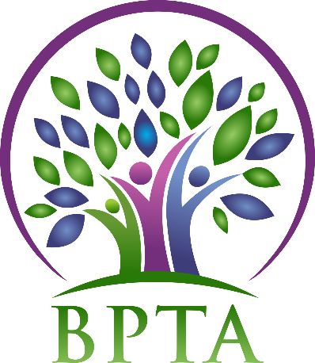
Beautiful Plains Teachers’ Association
Wednesday, September 16, 2020
Zoom Meeting

In Attendance: Heather Brister (HMK) Allen Hanke (HMK) Sheena Taylor (HMK) Robyn Forsman (Brookdale) Trish James (JM Young) Val Parayeski (NACI) Kerry Turner (NACI) Justine Burke (CC) Mike Adams (NACI) Denise Selewich (NACI) Susan Barteaux (RJW) Kelvin Hollier (NACI) Michelle Kolbe (NACI) Peter Reid (NACI) Ali Lazaruk (HMK) Raelynn Jacobson (Willerton) Ashlee Plett (HMK)
Regrets:
- Call to Order – 4:19

- Approval of Agenda
MOTION: moved by Allen and seconded by Trish that the agenda be approved as circulated. CARRIED
- Approval of Minutes from March 4, 2020
MOTION: moved by Allen and seconded by Trish that the minutes be approved as circulated. CARRIED
- Business Arising from Minutes

- Correspondence (circulated)

- Treasurer’s Report—Robyn Forsman
MOTION: Moved by Robyn Forsman and seconded by Trish that the Treasurer’s report for February 2020 be accepted as presented/amended. CARRIED
MOTION: Moved by Robyn Forsman and seconded by Allen that the Treasurer’s report for March 2020 be accepted as presented. CARRIED
MOTION: Moved by Robyn Forsman and seconded by Susan that the Treasurer’s report for April 2020 be accepted as presented. CARRIED
MOTION: Moved by Robyn Forsman and seconded by Trish that the Treasurer’s report for May-August 2020 be accepted as presented. CARRIED
- President’s Report — Heather Brister
Heather attended Presidents’ Training in August (Winnipeg).

- Board Coverage Report - none

- Committee Reports:
- Collective Bargaining — Kelvin Hollier
Kelvin will be attending the Collective Bargaining seminar on October 3 over zoom.

- Professional Development — Val Parayeski & Trish James
See attached

- Equity and Social Justice — Denise Selewich
See attached

- Liaison — Heather Brister
No report

- Workplace Safety & Health — Kerry Turner
Sept 22 over zoom

- Education Finance — Mike Adams
No report

- Indigenous Education Issues — Michelle Kolbe
No report

- Public Relations — Ali Lazaruk
The executive discussed ways to spend our PR budget for the year.

- Employee Benefits — Peter Reid
Benefits Newsletter has been sent out to all teachers.

- Wellness — Ashlee Plett
The executive discussed ways to spend our wellness budget.

- New Business
  - Induction of new BPTA members
Heather will be ordering some new toques to give to new BPTA members.

  - Executive meeting plan moving forward
Executive meetings will be held the first Wednesday of each month. We will continue to meet over zoom for the time being.

  - Use of our 25 days as according to the Collective Agreement
Inform Heather of any dates you are away for MTS Business.

- Board Meeting Coverage
October 20 Heather
November 17 Al
December 15 Trish
January 19 Sheena
February 16 Justine
March 16 Micky
April 20 Val
May 18 Robyn
June 15 Kelvin

- Next Meeting date and location: - Wednesday, October 7 over Zoom @ 4:15

- Adjournment – 5:19

**See attached reports below**

Professional Development Report – BPTA
September:
As everyone knows our September 21st Divisional In-service day has been cancelled and repurposed as a school day. The intent was to get as many “in school days” with the students as possible – in case something occurs like April – June of last year.
Trish participated in the remote Summer Seminar on August 18th, 2020. It was done via Zoom. There was discussion about professional development for the upcoming school year.
- MTS PD Day will still be occurring. Teachers in Beautiful Plains are able to attend MTS PD day even though it is a scheduled school day. Teachers need to complete the proper paperwork and have it approved prior to attending. Unfortunately- due to sub availability – not all teachers will/may be able to attend.
I did mention at this session that substitute availability for the entire year would probably be an issue for teachers in our division. (Not just for PD days).
There was a session hosted by Jennifer Abrams- Communicating in Challenging Times. She discussed the SCARF model which helps understand how messages can make people feel threatened. If anyone would like this info – I could send it.
S – STATUS
C- CERTAINTY
A-AUTONOMY
R-RELATEDNESS
F- FAIRNESS
There was a session about engaging from a distance. They discussed different ways of reaching people – video sharing, blogging, social networking, etc. They discussed some do’s and don’ts around these forms of communication.

The February 8th In-service Day is scheduled. We will be planning what this day will look like based on Public Health Recommendations.

MTS Virtual Summer Seminar - ESJ
August 18, 2020

Reminder for all members to connect with MTS: For the latest information on Back To School Information and FAQs
Visit http://www.mbteach.org/mtscms/

Concerns
- Health and safety of all - staff and students
- Continue to respect the Collective Agreements
- Teachers are the most reliable source of info for questions on teaching and learning
- Decisions made should be based on data and science
- Ongoing collaboration and communication between all education stakeholders is key

MTS continues to work on various concerns:
-mask mandate
-MTS PD DAY
-Lack of Substitute teachers
-Teacher workload
-Teacher pay
-Teacher sick days/STD

Other concerns
-working from home if self-isolating and not using sick days
-quality of education
-speciality teachers revamping their course or teaching something new
-cleaning
-refusal to work

Break Out Sessions for ESJ

-Live Well Work Well Be Well with Sylvia

-Mental Wellness and Resilience

