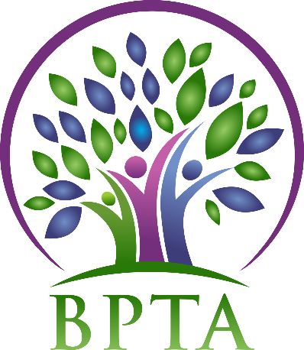
Beautiful Plains Teachers’ Association
Wednesday, February 5, 2020
Carberry, Manitoba

In Attendance: Heather Brister (HMK) Allen Hanke (HMK) Sheena Taylor (HMK) Robyn Forsman (Brookdale) Val Parayeski (NACI) Kerry Turner (NACI) Justine Burke (CC) JoAnn Freeman (NACI) Susan Barteaux (RJW) Kelvin Hollier (NACI) Michelle Kolbe (NACI) Ali Lazaruk (HMK)
Regrets: Trish James (JM Young) Raelynn Jacobson (Willerton) Mike Adams (NACI) Denise Selewich (NACI) Peter Reid (NACI)
- Call to Order – 4:45

- Approval of Agenda
MOTION: moved by Allen and seconded by Susan that the agenda be approved as amended. CARRIED
- Approval of Minutes from January 15, 2020
MOTION: moved by Robyn and seconded by Kerry that the minutes be approved as circulated. CARRIED
- Business Arising from Minutes
  - BPTA policies
Heather has sent out the updated policies to the membership for review.
MOTION: Moved by Allen and seconded by Ali that BPTA accept the policy changes as outlined in “Policies-Draft February 5, 2020” to go into effect July 1, 2020.
CARRIED

  - BPTA/Board Supper (April 21)
BPTA’s topic will be “Impacts of EAL/Cultural Diversity in the Classroom. Over the next month school reps will gather feedback from each school. A format for the presentation will be decided at our March meeting.

  - Local Electoral Officer
Claudette Christison has emailed out the procedures for the 2020/2021 elections.

- Correspondence (circulated)

- Treasurer’s Report—Robyn Forsman
MOTION: Moved by Robyn Forsman and seconded by JoAnn that the Treasurer’s report for January 2020 be accepted as presented. CARRIED
- President’s Report — Heather Brister
On February 3 Heather toured the division with MTS vice-president Nathan Martindale and COSL chariperson Myles Blahut. They visited Carberry Collegiate, RJ Waugh, Twilight Colony, Brookdale, NACI, NMS, HMK and Eden. They spent time visiting classrooms and answering questions from teachers and administrators.

- Board Coverage Report
January 21 – Trish February 4 – Kerry

- Committee Reports:
- Collective Bargaining — Kelvin Hollier
Staff officer Terri Hill will be attending our next BPTA meeting to go over updates regarding provincial bargaining and MTS news.

- Professional Development — Val Parayeski & Trish James
See attached

- Equity and Social Justice — JoAnn Freeman & Denise Selewich
JoAnn and Denise will attend the winter seminar on February 21 & 22 in Winnipeg.

- Liaison — Heather Brister
No report

- Workplace Safety & Health — Kerry Turner
Kerry will attend the winter seminar on February 22 in Winnipeg.

- Education Finance — Mike Adams
No report

- Indigenous Education Issues — Michelle Kolbe
Michelle will attend the winter seminar on February 21 & 22 in Winnipeg.

- Public Relations — Ali Lazaruk
BPTA will be handing out hot chocolate/fries at public skating in the following communities:
Neepawa (February 23)—Heather, Ali, Sheena, Al
Brookdale (February 19)—Robyn
Carberry (February 9)—Justine and Susan
Eden (February 23)—Raelynn
Ali will notify the Neepawa Banner of dates.

- Employee Benefits — Peter Reid
No report

- New Business
  - MTS Provincial AGM – May 21-23, 2020
We will finalize delegates at the March meeting.
  - Neepawa Banner Ad MOTION: Moved by JoAnn and seconded by Susan that BPTA takes out a business card size ad in the congratulations spread of the Banner recognizing the opening of Neepawa Middle School.
CARRIED
- Board Meeting Coverage
February 18 – Sheena March 3 – Allen March 17 – Heather April 7 – Val April 21 – Justine May 5 – Mike May 19 – Raelynn June 2 – Peter June 16 – Denise

- Next Meeting date and location: - Wednesday, March 4 @ 4:30 (HMK)

- Adjournment – 5:55 p.m.

**See attached reports below**

February Professional Development Report – BPTA
A PD Committee meeting was held January 20th at the Division Office.
- February 10th, 2020 – Peg Dawson at the Carberry Hall. Topic is Executive Functioning. There is a free parent session in the evening at the Carberry School.
- September 21st, 2020 will be a divisional PD event. Kevin Chief will be the presenter.
- Planning for the February 2021 in-service was discussed.
Val and Trish will attend the PD-Chairs Winter Seminar in Winnipeg on February 7 and 8th.

