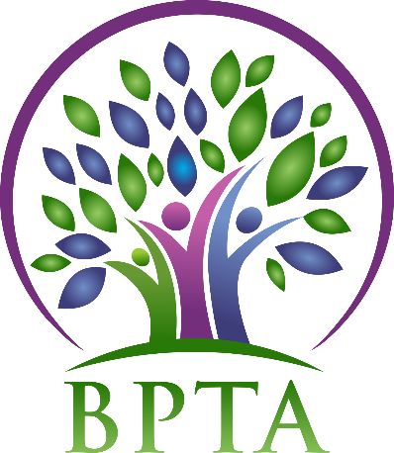
Beautiful Plains Teachers’ Association
Wednesday, March 4, 2020
Neepawa, Manitoba

In Attendance: Heather Brister (HMK) Allen Hanke (HMK) Sheena Taylor (HMK) Trish James (JM Young) Val Parayeski (NACI) Kerry Turner (NACI) JoAnn Freeman (NACI) Kelvin Hollier (NACI) Peter Reid (NACI) Ali Lazaruk (HMK) Raelynn Jacobson (Willerton)
Regrets: Susan Barteaux (RJW) Michelle Kolbe (NACI) Robyn Forsman (Brookdale) Justine Burke (CC) Mike Adams (NACI) Denise Selewich (NACI)
- Call to Order – 4:35

- Approval of Agenda
MOTION: moved by Kerry and seconded by Allen that the agenda be approved as circulated. CARRIED
- Approval of Minutes from
MOTION: moved by Allen and seconded by JoAnn that the minutes be approved as circulated. CARRIED
- Business Arising from Minutes
  - BPTA/Board Supper (April 21)
BPTA’s topic is “Impacts of EAL/Cultural Diversity in the Classroom.” Information has been gathered from some schools, and we will continue to gather information and decide how it is to be presented at our April meeting.

  - MTS AGM – delegates and alternates

- Correspondence (circulated)

- Treasurer’s Report—Robyn Forsman
Tabled to April meeting.
- President’s Report — Heather Brister
Heather attended Indigenous Voice and Action/ESJ and WSH winter seminars in Winnipeg.

Board Coverage Report
February 18 Sheena
March 3 Allen

- Committee Reports:
- Collective Bargaining — Kelvin Hollier
Terri Hill will be attending our next executive meeting to provide insights and updates regarding Bill 28, Bill 2 and provincial bargaining.

- Professional Development — Val Parayeski & Trish James
No report

- Equity and Social Justice — JoAnn Freeman & Denise Selewich
See attached

- Liaison — Heather Brister
No report

- Workplace Safety & Health — Kerry Turner
See attached

- Education Finance — Mike Adams
See attached

- Indigenous Education Issues — Michelle Kolbe
No report

- Public Relations — Ali Lazaruk
Hot Chocolate/Fries were handed in each community. The total money spent was $363.97. Ali is looking into ways we can spend the rest of the funds.

- Employee Benefits — Peter Reid
No report

- New Business
a) Budget Consultation Meeting
Heather, Al, Val and Trish attended the budget meeting in Neepawa and Kelvin attended in Carberry. Increasing enrolment and new immigration laws were topics of discussion.

- Board Meeting Coverage
March 17 Heather
April 7 Val April 21 Justine May 5 Mike May 19 Raelynn June 2 Peter June 16 Denise

- Next Meeting date and location: - Wednesday, April 8 @ HMK (4:30)

- Adjournment – 5:45 p.m.

**See attached reports below**

WSH Winter 2020 Seminar Winnipeg, Feb. 22, 2020
Jack Slessor presented on “Building a SAFER Workplace” which focused on WSH Act Legislation, rights and responsibilities of everyone in the workplace in promoting a positive safety culture, and the 11 required elements of a WSH program in the workplace. Shannon Gander, from Life Work Wellness, presented on matters of resilience and teacher strategies for mental health protection, looking out for colleagues and oneself, and resources available for those dealing with mental health issues. Break-out sessions: discussed what type of WSH Committee divisions have, dealing with workplace conflict and having difficult conversations, and how the MTS Code of Professional Practice applies, and dealing with the after-effects of traumatic incidents and what can teachers do to cope and what resources are available for support

BPTA Ed. Finance Report March/2020
Attended:
Feb 8th/Wpg: Ed. Finance Seminar/M. Adams
- Kent McPherson EFSC Chair
- Joseph Warbanski: “Provincial Financial Outlook”.
- Joseph Warbanski: “Provincial Funding Announcement”.
  - Divisional Impacts
- “Ear to the Ground”
  - round table discussions on potential implications of Prov. Funding on MTS locals.
- Update on Bill 28 and Bill 9 – Tom Paci, Asst. Gen. Secretary

ESJ and Indigenous Chairs` Winter Seminar
February 21 and 22, 2020

- VIdeo: We Are What We Learn - MTS Campaign
- The Truth About Climate Change Advocacy Youth Group eco-anxiety`
- Climate Justice and Indigenous Peoples - Chickadee Richard
- Green Action Centre - Active Transportation
- MB Centre for International Cooperation - Grace Van Mil
- Canadian Centre For Policy Alternative - Molly McCracken
- Managing Change and Advocacy - Leading Professional Learning -Cathryn Smith - Leading Professional Learning Game
- Topic Grids and Dilemmas of Practices
- Process and Action Whip Around

Upcoming - Summer Seminar - August 18-21, 2020 - Brandon, MB

