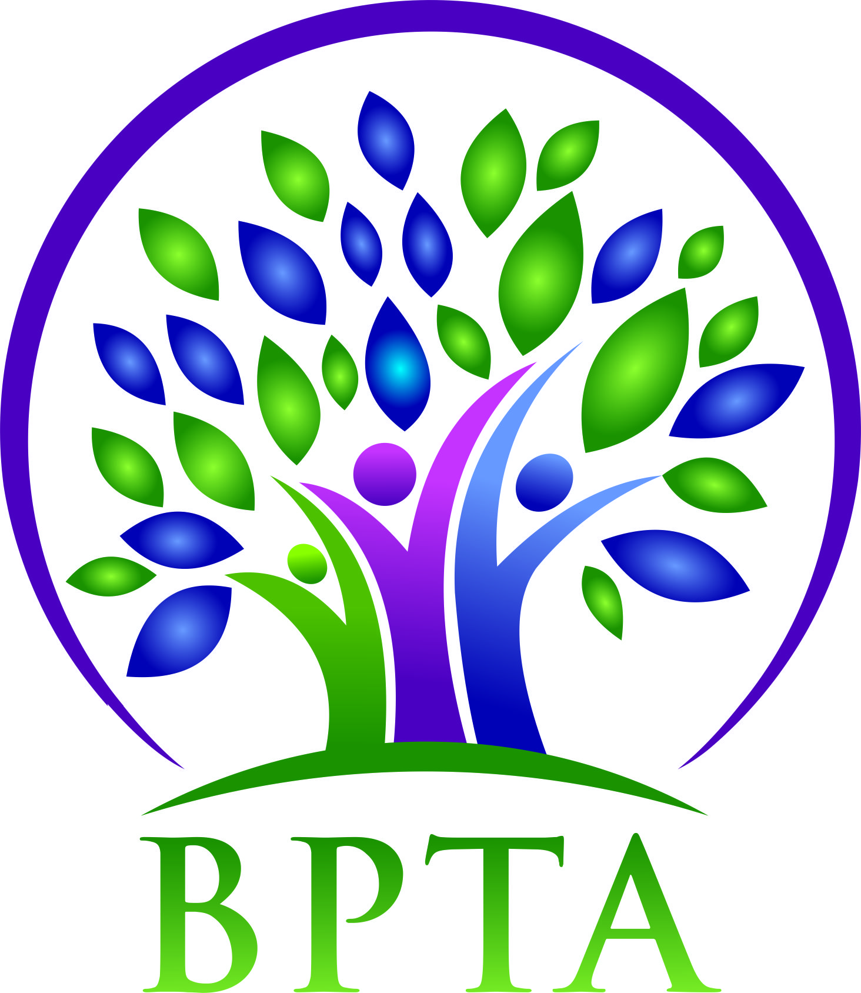
Beautiful Plains Teachers’ Association
Wednesday, May 4, 2022
Neepawa, MB

In attendance: Allen Hanke (HMK) Robyn Forsman (Brookdale)
Sheena Taylor (HMK) Kelvin Hollier (NACI)
Val Parayeski (NMS) Trish James (JM Young)
Mike Adams (NACI) Kerry Turner (NACI)
Denise Selewich (NMS) Michelle Kolbe (NMS)
Ashlee Plett (HMK) Raelynn Jacobson (Willerton)
Peter Reid (NACI)

Regrets: Susan Barteaux (RJ Waugh) Brent Boyle (CC)

- Call to Order - 4:32

- Approval of Agenda
Motion: Moved by Ashlee and seconded by Mike that the agenda be accepted as amended.
CARRIED

- Approval of Minutes
Motion: Moved by Trish and seconded by Raelynn that the minutes for April 2022 be accepted as presented.
CARRIED

- Business Arising from Minutes
  - MTS Provincial Council May 26-28: delegates, resolutions, PX candidates
Al and Sheena will be delegates this year.
  - BPTA elections
Last call for elections was April 29.

- Treasurer’s Report
Motion: Moved by Robyn and seconded by Peter that the treasurer’s report for April be accepted as presented.

Robyn went over the proposed budget for the 2022-2023 school year.

- President’s Report-Allen Hanke
See attached

- Board Coverage Report
April 19 - Kerry
May 3 - Robyn

- Committee Reports
  - Collective Bargaining-Kelvin Hollier
Letter to open negotiations on behalf of all School Divisions has been sent
to the Education Minister and all School Boards.
  - Professional Development-Val Parayeski & Trish James
See attached
  - Equity & Social Justice-Denise Selewich
Denise will attend the Spring Regional meeting May 5 in Brandon
  - Liaison-Allen Hanke
No report
  - Workplace Safety & Health-Kerry Turner
The next divisional WSH meeting will be June 7.
  - Education Finance-Mike Adams
Mike will attend the Spring Regional meeting on May 10 in Brandon.
  - Indigenous Education Issues-Michelle Kolbe
No report
  - Public Relations-vacant

  - Employee Benefits-Peter Reid
No report
  - Wellness-Ashlee Plett
The latest Wellness cheques have been distributed to schools.

- New Business
  - BPTA AGM: date, format/location
Our AGM will be in-person at NACI June, 1 2022 @ 4:15.
  - retirements, leaving service, recognition

- Board Coverage
May 17 - Allen
June 7 - Val
June 21 - Kerry

- Next Meeting-AGM-Wednesday, June 1 @ 4:15 {NACI}

- Adjournment - 5:15

Professional Development Report-May 2022
Val attended the spring regional professional development meeting in Brandon on April 28th. Divisions from southwest discussed presenters that they have had over the last couple of years. We also discussed how professional development is managed in different divisions. A shortage of substitutes was highlighted as a concern in all divisions.

The professional development summer seminar will be held in Brandon on August 24th and 25th. Val and Trish will be attending.

The PD committee is in the process of planning next year’s divisional in-services. On Monday, September 19th, we are hoping to have 2 presenters from EDCAN on the theme of being the best you can be. The in-service will be in Neepawa. Our second divisional in-service will be in Carberry. We are planning to have Tess Lelond as a keynote with breakout sessions for the remainder of the day.

