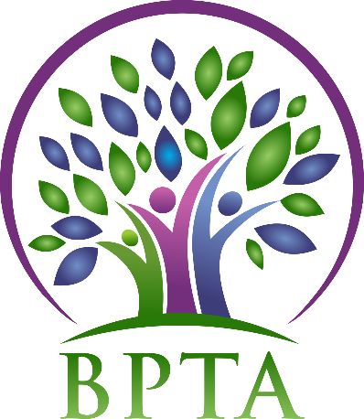
Beautiful Plains Teachers’ Association
Wednesday, April 3, 2019
Neepawa, Manitoba

In Attendance: Heather Brister (HMK) Allen Hanke (HMK) Robyn Forsman (Brookdale) Trish James (JM Young) Val Parayeski (NACI) Kerry Turner (NACI) Justine Burke (CC) Mike Adams (NACI) JoAnn Freeman (NACI) Denise Selewich (NACI) Susan Barteaux (RJW) Kelvin Hollier (NACI) Peter Reid (NACI) Karla Hackewich (Twilight)
Regrets: Sheena Taylor (HMK) Rosalie Tarleton (NACI)
- Call to Order – 4:30 p.m.

- Approval of Agenda
MOTION: moved by Susan Barteaux and seconded by Allen Hanke that the agenda be approved as circulated. CARRIED
- Approval of Minutes from March 2019
MOTION: moved by Val Parayeski and seconded by JoAnn Freeman that the minutes be approved as circulated. CARRIED
- Business Arising from Minutes
  - BPTA/Board Supper (March 19)
The board supper was held on March 19 at the division office. Both presentations were excellent and informative. We feel fortunate to be able to sit with the board each year and discuss education topics that affect our students. BPTA would like to thank all the teachers for their input into our presentation, as well as the board members for their hard work.

  - BPTA By Laws/Constitution
Heather will send the new By Laws and Constitution on to Dan Turner.

  - Wage disparity question
Heather emailed those running in the upcoming MTS election our question regarding wage disparity throughout the province. She received three responses, and the overall consensus was that all teachers in Manitoba should be making the same amount of money, and that the wage disparity would be a top priority if/when provincial bargaining begins.

  - Liaison
The Liaison meeting will be May 7 at the division office. BPTA’s topic will be BPSD’s inclement weather policy-specifically policies GDB and EEA.

  - Land Acknowledgement
Land acknowledgment will be read at all divisional PD days.

- Correspondence (circulated)

- Treasurer’s Report—Robyn Forsman
MOTION: Moved by Robyn Forsman and seconded by Allen Hanke that the Treasurer’s report for March 2019 be accepted as presented. CARRIED
- President’s Report — Heather Brister
Heather will be attending the Regional Presidents’ Meeting in Brandon on April 23 (all day) and the Provincial Presidents’ Council in Winnipeg on April 27 (all day).

- Board Coverage Report
March 19 Justine April 2 JoAnn

- Committee Reports:
- Collective Bargaining — Kelvin Hollier
Kelvin attended the bargaining seminar on March 16. Topics included the Avis Glaze announcement, and provincial bargaining.
- Professional Development — Val Parayeski & Trish James
See attached

- Equity and Social Justice — JoAnn Freeman & Denise Selewich
No report

- Liaison — Heather Brister
See new business

- Workplace Safety & Health — Kerry Turner
Kerry attended the Divisional WSH meeting on March 5th.

- Education Finance — Mike Adams
Mike will attend the Ed Finance meeting on April 15.

- Indigenous Education Issues — Rosalie Tarleton
No report

- Public Relations — Karla Hackewich
Karla and Susan will deliver books to the dental and doctor’s offices this week.

- Employee Benefits — Peter Reid
No report
- New Business
  - BPTA AGM: date, agenda, location, election
2019 AGM will be held in Carberry on May 29 at 4:45. The meeting will be held in the Carberry Collegiate MPR. Prizes will be the same as last year, one $80 draw, and twenty $50 draws. We will vote on the new by laws and constitution. Heather has emailed out both documents. If you have questions please email Heather, and they will be addressed at AGM. Babysitting and snacks will be provided again this year.

  - Policies
The executive reviewed the policies that had been changed (1.4, 1.8. 1.9, 3.10, and grad scholarships). We will look them over again and bring changes and suggestions to our next meeting.
  - 2019/2020 Budget
Robyn reviewed our 2018-19 budget as well as our proposed 2019-20 budget. The executive discussed some changes, and Robyn will bring those to the next meeting. The budget will be approved at AGM.
  - Pension Sustainability Seminar – Minnedosa, April 11 at 5:30

- Board Meeting Coverage
April 16 Val May 7 Karla May 21 Kerry June 4 Susan June 18 Peter
- Next Meeting date and location: - Wednesday, May 1st in Carberry @ 4:45

- Adjournment – 6:46 p.m.

**see attached reports below**

Beautiful Plains Teachers’ Association PD Report - April

The PD committee is preparing for our 2019/2020 Divisional In-services. We have booked Kevin Chief for the September In-service with a focus of Diversity and Inclusion around the topic of Truth and Reconciliation. The PD committee has also booked Peggy Dawson around the topic of Executive Functioning for our February Divisional In-service.

Trish and Val will be attending the Spring Regional PD Meeting in Brandon on April 30th.

The PD committee has made a PD Needs Assessment survey for all BPSD teachers to complete to help the committee with planning of future PD sessions. The survey will be sent out in the near future.

