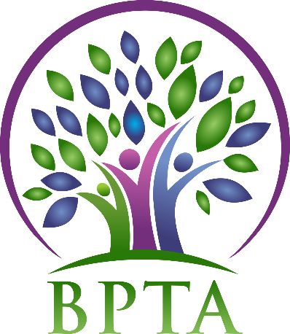
Beautiful Plains Teachers’ Association
Wednesday, January 15, 2019
Neepawa, Manitoba

In Attendance: Heather Brister (HMK) Allen Hanke (HMK) Sheena Taylor (HMK) Robyn Forsman (Brookdale) Kerry Turner (NACI) Justine Burke (CC) Mike Adams (NACI) Denise Selewich (NACI) Susan Barteaux (RJW) Michelle Kolbe (NACI) Peter Reid (NACI) Ali Lazaruk (HMK)
Regrets: Trish James (JM Young) Val Parayeski (NACI) JoAnn Freeman (NACI) Kelvin Hollier (NACI)
- Call to Order – 4:28

- Approval of Agenda
MOTION: moved by Allen and seconded by Peter that the agenda be approved as amended. CARRIED
- Approval of Minutes from December 4, 2019
MOTION: moved by Peter and seconded by Denise that the minutes be approved as circulated. CARRIED
- Business Arising from Minutes
  - Public Relations vacancy
MOTION: Moved by Allen and seconded by Peter that Ali Lazaruk take over the Public Relations portfolio effective January 15, 2020.
CARRIED
  - Policies
Heather has updated the policy changes in comparison with our existing policies. Members will receive a copy for review before the new policies are passed.

  - BPTA Board Supper
The board supper will be April 21 at 5:20 at the division office. BPTA’s topic will be Impacts of EAL/Cultural Diversity in the Classroom. We discussed how best to gather and present information that will showcase all teachers and learners across our division.

- Correspondence

- Treasurer’s Report—Robyn Forsman
MOTION: Moved by Robyn and seconded by Kerry that the Treasurer’s report for November be accepted as presented.
MOTION: Moved by Robyn and seconded by Allen that the Treasurer’s report for December be accepted as presented. CARRIED
- President’s Report — Heather Brister
Heather attended the South Central Presidents’ Meeting (Brandon) and the President’s Council Meeting (Winnipeg).

- Board Coverage Report
December 17 – JoAnn January 7 – cancelled

- Committee Reports:
- Collective Bargaining — Kelvin Hollier
No report

- Professional Development — Val Parayeski & Trish James
No report

- Equity and Social Justice — JoAnn Freeman & Denise Selewich
No report

- Liaison — Heather Brister
No report

- Workplace Safety & Health — Kerry Turner
No report

- Education Finance — Mike Adams
Mike will attend the winter seminar on February 8 in Winnipeg.

- Indigenous Education Issues — Michelle Kolbe
Michelle will attend the winter seminar on February 21 in Winnipeg.

- Public Relations — Ali Lazaruk
BPTA will be handing out a treat at public skating in Neepawa, Brookdale, Eden and Carberry. We will finalize dates at our February meeting.

- Employee Benefits — Peter Reid
No report

- New Business
  - Local Electoral Officer – By Laws Part 9
As per BPTA by laws the executive will appoint a local electoral officer for the upcoming elections.

- Board Meeting Coverage
January 21 - Trish
February 4 - Sheena
February 18 – Trish
March 3 - Allen
March 17 - Kerry
April 7 - Val
April 21 - Justine
May 5 - Mike
May 19 - Raelynn
June 2 - Peter
June 16 - Denise

- Next Meeting date and location: - Wednesday, February 5 @ CC—4:45

- Adjournment – 6:05

