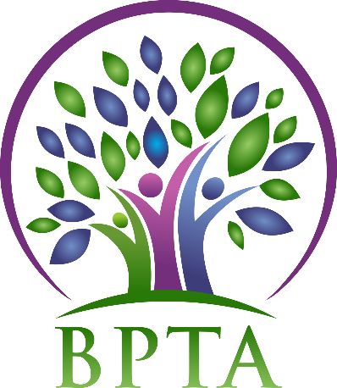
Beautiful Plains Teachers’ Association
Wednesday, May 1, 2019
Carberry, Manitoba

In Attendance: Heather Brister (HMK) Allen Hanke (HMK) Sheena Taylor (HMK) Robyn Forsman (Brookdale) Trish James (JM Young) Val Parayeski (NACI) Kerry Turner (NACI) Justine Burke (CC) Mike Adams (NACI) JoAnn Freeman (NACI) Denise Selewich (NACI) Rosalie Tarleton (NACI)
Regrets: Susan Barteaux (RJW) Kelvin Hollier (NACI) Peter Reid (NACI) Karla Hackewich (Twilight)
- Call to Order – 4:49

- Approval of Agenda
MOTION: moved by Kerry Turner and seconded by Allen Hanke that the agenda be approved as amended. CARRIED
- Approval of Minutes from April 2019
MOTION: moved by Robyn Forsman and seconded by Allen Hanke that the minutes be approved as circulated. CARRIED
- Business Arising from Minutes
  - BPTA By Laws/Constitution
Dan Turner from MTS reviewed our by laws and constitution. We will review changes at AGM on May 29.

  - Wage Disparity Question
Heather forwarded the answers from several candidates running for Provincial Executive.

  - Liaison – May 7 at 5:00 (Division Office)
Our topic will be divisional policies around school closures due to inclement weather and cold temperatures. Heather, Allen, Trish, Peter and Karla will attend the meeting. Heather has made a list of questions that have come from members, as well as discussion at executive meetings.

  - BPTA AGM
AGM will be held on May 29 in Carberry at 4:45. We will meet in the Carberry Collegiate MPR. Posters have been posted up in schools.

  - Policies - review
Tabled to September meeting

  - 2019/2020 Budget
MOTION: Moved by Robyn Forsman and seconded by JoAnn Freeman that the 2019/2020 budget be accepted as presented. CARRIED
- Correspondence (circulated)

- Treasurer’s Report—Robyn Forsman
MOTION: Moved by Robyn Forsman and seconded by Trish James that the Treasurer’s report for April 2019 be accepted as presented. CARRIED
- President’s Report — Heather Brister
See attached

- Board Coverage Report
April 16 – Val

- Committee Reports:
- Collective Bargaining — Kelvin Hollier
No report

- Professional Development — Val Parayeski & Trish James
See attached

- Equity and Social Justice — JoAnn Freeman & Denise Selewich
No report

- Liaison — Heather Brister
See Business Arising

- Workplace Safety & Health — Kerry Turner
The next WSH meeting will be June 4 at the Division Office

- Education Finance — Mike Adams
See attached

- Indigenous Education Issues — Rosalie Tarleton
No report

- Public Relations — Karla Hackewich
Books were delivered to the doctor and dentist office in Neepawa and Carberry. Response from Neepawa offices was very positive and they were happy to receive them.

- Employee Benefits — Peter Reid
No report

- New Business
  - MTS Golf Tournament
This year’s golf tournament will be June 15 in Elm Creek. If interested, please contact Heather for entry form.

  - Submission to MB’s Commission on K-Gr. 12 Education April 2019
All members are encouraged to review the submission, and complete the online K-12 Education Review Survey

  - Student Bursaries
MOTION: Moved by Rosalie Tarleton and seconded by Val Parayeski that Sienna Carritt and Alison Byram receive $150 each for bursaries to assist with the cost of Encounters with Canada.
CARRIED
  - Education Review Survey
Heather shared MTS submission to Manitoba’s Commission on Kindergarten to Grade 12 Education. The submission will be sent to all members next week. Members are encouraged to review the submission and complete the online survey.
  - Recognition Evening-retirement gifts

- Board Meeting Coverage
May 7 Karla
May 21 Kerry
June 4 Susan
June 18 Peter

- Next Meeting date and location: - Wednesday, May 29 at CC—4:45 (AGM)
Wednesday, September 11 at NACI—4:30

- Adjournment – 5:53

**See attached reports below**

President’s Report—May 2019
Provincial Bargaining Government tried to introduce Provincial Bargaining legislation in March. Opposition successfully delayed that legislation from being introduced in the Spring Session. The earliest time the legislation could be introduced is Fall of 2019.
Education Review Public consultations have begun and continue to be held. The first session was a round table discussion with a question and answer time. The next meetings format was changed, and it did not allow for a question and answer period.
I attended the Regional President’s meeting in Brandon on April 23, and President’s council in Winnipeg on April 27.
BPTA is registered for MTS AGM on May 23-25. Summer session will be held in Hecla again this year. Attendees will be decided at a later date.

Ed. Finance Report—May 2019
Attended Western Rep Meeting April 15th in Brandon
* Discussed Manitoba Provincial Budget
* Discussed Review of Canadian Centre for Policy Alternatives.
* K-12 Public Ed. Review
* Provincial and local enrolment trends
* Discussion of Possible Early Provincial Election
* Update Bill 28

BPTA PD Report—May 2019

The PD committee is preparing for our 2019/2020 Divisional In-services. We have booked Kevin Chief for the September In-service with a focus of Diversity and Inclusion around the topic of Truth and Reconciliation. We have also booked Peggy Dawson around the topic of Executive Functioning for our February Divisional In-service.

The PD committee has made a PD Needs Assessment survey for all BPSD teachers to complete to help the committee with planning of future PD sessions. The survey was sent out today.

The next PD meeting is on Wednesday, May 15th at the Division Office at 4:30pm.

Both Val and Trish attended the regional meeting in Brandon on April 30.

