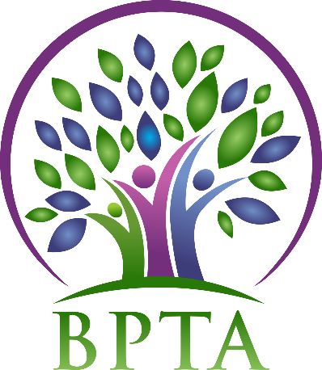
Beautiful Plains Teachers’ Association
Wednesday, October 2, 2019
Neepawa, Manitoba

In Attendance: Heather Brister (HMK) Sheena Taylor (HMK) Robyn Forsman (Brookdale) Val Parayeski (NACI) Kerry Turner (NACI) Justine Burke (CC) Mike Adams (NACI) Denise Selewich (NACI) Susan Barteaux (RJW) Kelvin Hollier (NACI) Michelle Kolbe (NACI) Peter Reid (NACI) Karla Hackewich (Twilight)
Regrets: JoAnn Freeman (NACI) Trish James (JM Young) Allen Hanke (HMK)
- Call to Order – 4:30

- Approval of Agenda
MOTION: moved by Karla and seconded by Val that the agenda be approved as circulated. CARRIED
- Approval of Minutes from September 11, 2019
MOTION: moved by Val and seconded by Susan that the minutes be approved as presented. CARRIED
- Business Arising from Minutes
  - BPTA Policies
The executive continued to review policies.
  - Introduction of new members: feedback
Feedback from the induction to BPTA at our divisional PD was positive, and we will continue to do it this way in the future.

- Correspondence (circulated)

- Treasurer’s Report—Robyn Forsman
MOTION: Moved by Robyn and seconded by Karla that the Treasurer’s report for September be accepted as presented. CARRIED
Robyn outlined information she received from her Treasurer’s workshop. The EI rebate for this year is expected to be about $70 per full time staff which will be close to $10,000.
- President’s Report — Heather Brister
Heather will be attending president’s council on October 21 in Brandon.

- Board Coverage Report
September 17: Trish
October 1: Susan

- Committee Reports:
- Collective Bargaining — Kelvin Hollier
Kelvin will be attending the CB fall seminar on October 5 in Winnipeg.

- Professional Development — Val Parayeski & Trish James
See attached report below

- Equity and Social Justice — JoAnn Freeman & Denise Selewich
JoAnn and Denise will be attending the ESJ winter seminar in Winnipeg on November 15 and 16.

- Liaison — Heather Brister
No report

- Workplace Safety & Health — Kerry Turner
See attached

- Education Finance — Mike Adams
Mike will be attending the Ed Finance fall seminar on October 19 in Winnipeg.

- Indigenous Education Issues — Michelle Kolbe
No report

- Public Relations — Karla Hackewich
Karla will be stepping down as PR Chair in December as she is going on maternity leave.

- Employee Benefits — Peter Reid
No report

- New Business
  - Minutes: distribution/posting
The executive reviewed MTS protocol with regards to distribution on meeting minutes. Going forward meeting minutes will not be posted until they have been approved at the next month’s BPTA meeting. Any time sensitive information will be communicated through email or school reps following the meeting.

  - Teacher education bursary request
MOTION: Moved by Susan and seconded by Denise that BPTA award Peter Reid a teacher bursary in the amount of $379 dollars for his French course.
CARRIED

- Board Meeting Coverage
October 15 Karla
November 5 Robyn
November 19 Peter
December 3 Justine
December 17 JoAnn

- Next Meeting date and location: - Wednesday, November 6 @ 4:45 (Carberry)

- Adjournment – 6:16 p.m.

**see attached reports below**
Professional Development Report – October BPTA

Our next PD committee meeting will be Monday, October 21st at the Division Office at 4:30 p.m.
The PD Fall Seminar will be November 1st and 2nd in Winnipeg. Val and I will attend.
Feedback from Kevin Chief was positive.
February In-service will be in Carberry. It is Peggy Dawson – Executive Functioning
The PD Committee is reviewing the expenses we will cover for teacher PD days. We will be giving an information letter on this topic to each teacher in the near future.

Workplace Safety and Health Report – October
WSH Divisional meeting was on Sept. 24. Allen Hanke went in my stead. Waiting to hear back from Shannon Bayes on a date for the annual school inspections which will be in the north end of the division this year.
I will attend the MTS/MSBA fall WSH training session in Brandon on Nov. 14.

