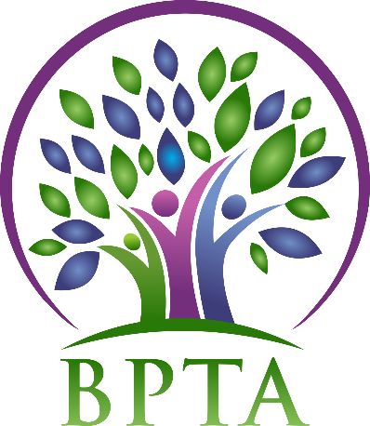
Beautiful Plains Teachers’ Association
Wednesday, September 11, 2019
Neepawa, Manitoba

In Attendance: Heather Brister (HMK) Allen Hanke (HMK) Sheena Taylor (HMK) Robyn Forsman (Brookdale) Trish James (JM Young) Val Parayeski (NACI) Kerry Turner (NACI) Justine Burke (CC) Mike Adams (NACI) JoAnn Freeman (NACI) Denise Selewich (NACI) Susan Barteaux (RJW) Kelvin Hollier (NACI) Michelle Kolbe (NACI) Peter Reid (NACI) Karla Hackewich (Twilight)
Regrets:
- Call to Order – 4:31 p.m.

- Approval of Agenda
MOTION: moved by JoAnn and seconded by Denise that the agenda be approved as circulated. CARRIED
- Approval of Minutes from May 1, 2019
MOTION: moved by Allen and seconded by Peter that the minutes be approved as circulated. CARRIED
- Business Arising from Minutes
  - Constitution and By-Laws
Votes were as follows:
By-Laws: No-13 Yes-106 (82%)
Constitution: No-11 Yes-109 (90.8%)
Therefore, both documents passed and have been approved by MTS.
MOTION: Moved by Mike and seconded by Karla that the ballots from the BPTA constitution and by-laws vote from May 2019 be destroyed. CARRIED
  - Policies
Now that our constitution and by laws have been updated the executive will work on updating the BPTA policies.

- Treasurer’s Report—Robyn Forsman
MOTION: Moved by Robyn and seconded by Trish that the Treasurer’s report for June 2019 be accepted as presented. CARRIED
MOTION: Moved by Robyn and seconded by Peter that the Treasurer’s report for July/August 2019 be accepted as presented. CARRIED
Robyn will attend the Treasurer’s seminar on September 27 in Winnipeg.
- President’s Report — Heather Brister
Heather attended the new teacher orienation on August 28 at the division office.

- Committee Reports:
- Collective Bargaining — Kelvin Hollier
Kelvin will be attending the fall seminar on October 5 in Winnipeg.

- Professional Development — Val Parayeski & Trish James
*see attached

The division would like all employees to have Mental Health First Aid. There are 5 sessions available throughout this year.

- Equity and Social Justice — JoAnn Freeman & Denise Selewich
No report

- Liaison — Heather Brister
The executive reviewed the minutes from the May Liaison meeting. There will be a follow up meeting with the board sometime in October.

- Workplace Safety & Health — Kerry Turner
The workplace safety and health divisional meeting will be September 24 at 1:30. Al will be attending on behalf of BPTA.

- Education Finance — Mike Adams
Mike will be attending the Ed Finance fall seminar on October 19.

- Indigenous Education Issues — Michelle Kolbe
No report

- Public Relations — Karla Hackewich
No report

- Employee Benefits — Peter Reid
Peter will be attending the fall seminar on October 18 and 19 in Winnipeg.

- New Business
  - Induction of new BPTA members
A short introduction of new BPTA members will take place at the divisional PD on September 16.

  - Executive meeting rotation
MOTION: Moved by Susan and seconded by Allen that BPTA meetings be held on a rotation of two meetings in Neepawa and one meeting in Carberry for the 2019-2020 school year.
CARRIED

- Board Meeting Coverage
September 17 Trish
October 1 Susan
October 15 Karla
November 5 Robyn
November 19 Peter
December 3 Justine
December 17 JoAnn

- Next Meeting date and location: - Wednesday, October 2 @ NACI—4:30

- Adjournment – 5:46

**See attached reports below**
Professional Development Report – BPTA September 2019
Our first divisional PD meeting was held on Monday, September 9th. We discussed the upcoming PD day on September 16th with Kevin Chief. The topic is Diversity and Inclusion. This In-service is at the Yellowhead Centre starting at 9:00 a.m. Lunch will be provided. New Staff welcome will occur.
Our second Divisional PD day is planned for February 10th. Our presenter is Peggy Dawson and the topic is Executive Functioning. It will take place at the Carberry Hall. We are also planning a free Parent session in the evening.
We will do Land Acknowledgement at the in-services this year- this direction is from BPTA.
LIFT sessions opened for registration on September 3rd. MTS PD day sessions are also open for registration.
MTS hosts several in-services throughout the year. Teachers can visit the website to view the various in-services being offered this year. (ex. FAB 5)
If anyone has names for presenters or topics. You can forward this information to Val or Trish, or any committee member.
The PD mileage rate was discussed at the meeting and will remain at $0.25/km for the 2019-2020 school year. This allows most money to go towards PD opportunities rather than expenses.
Our next PD meeting will be October 21st @ 4:30 at the Division office.

